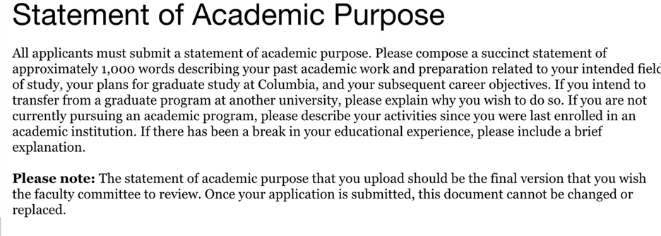As a Communication and Psychology double major, I undertook a number of multidisciplinary research projects during my undergraduate years, through which my keen interest in the dynamic interactions between the human brain and mediated messages has been promoted step by step. However, through my professional and lab experiences, I realized that, without strategic use of data, any attempt to understand this complex topic is in vain. I am therefore prompted to pursue a Master’s of Arts degree in Quantitative Methods in the Social Sciences (QMSS) at Columbia University, with an experiments focus, to equip myself with knowledge and skill sets necessary for exploration at the intersection of communication, technology and neuroscience.

During my internship at Tencent Online Media Group in 2017, as a news writer, I was responsible to produce news stories for the Global News Channel. The most challenging part is selecting the topic among large amounts of information catering to user preferences in a daily basis. To tackle with this challenge, I paid close attention to user responses including their comments and page views, which led to my discovery that Tencent users were into articles with visual aids and historical anecdotes. I shared my observations with my colleagues and improved my articles accordingly, which increased the number of reads by over fifty times. I was impressed by the power of digital trace data for understanding customer preference to increase product or service effectiveness, and started to interested in collecting and analyzing those digital trace data in an automated fashion through the application of web service and machine learning algorithms.

Realized the importance of data analytics in my internship experience, I began to develop data analysis skills as a research assistant at the Media Neuroscience Lab at University of California, Santa Barbara (UCSB). I mainly worked on two ongoing projects, one of them was a functional Magnetic Resonance Imaging (fMRI) study aimed at investigating brain networks underlying cognitive and perceptual processing during video game play, and the other focused on developing a narrative analysis system so as to examine the dynamics between moral domains in mediated narratives and audience response. In these two projects, I assisted the researchers to set up fMRI, run participants at the computer lab, and code categories of moral information in news data using Excel. Most importantly, I gained valuable insights into how automated computational methods and hand coding could be used for content analysis of news articles, as well as how neuroimaging technology could be harnessed to enrich mass communication research from a neurophysiological perspective.

Currently, I am working on an independent research project under the supervision of Dr. Rene Weber at the Media Neuroscience Lab. As a bilingual, I am interested in how juggling two tasks involving media use in different languages affect task performance among bilingual college students. Through the literature review, I realized that this area of research was in its incipient stage and thus decided to design an exploratory study. I constructed an online picture-word matching task accompanied by audiobook clips in English, Mandarin and Spanish using PsychoPy, a software package in Python. To smooth the designing process, I programmed an image sorter that could extract words from file names to help me organize numerous pictures. So far, I have collected data from 80 participants and analyzing the data using the statistical program R. An extended abstract of the study has been submitted to International Communication Association and the findings will be presented at ICA’s 2019 conference. I believe this study will shed some light on media-utilization behaviors among bilinguals and provide customer insights for digital media companies.

In addition to my rich research experiences, I am also taking online courses in programming (R and Python), probability and data to sharpen my quantitative skills to prepare for the QMSS program. Furthermore, my solid substantial background also makes me a promising candidate for your program. Throughout my undergraduate years, I took a variety of courses that allowed me to gain a systematic understanding of psychology, neuroscience and communication from different perspectives, for example, *Organizational Communication, Small Group communication, Cognitive Psychology* and *Social Networks.*

I intend to further my exploration in communication and psychology from a quantitative prospective through the courses QMSS offers. During my undergraduate social networks class, I was introduced to emergent structures, relational dynamics and networks across levels, types and contents. I am curious about how to maximize the benefits of this heightened connectivity. *Social Network Analysis* taught by the program director of QMSS, Dr. Greg Eirich, could supplement my knowledge from a methodological approach, though high-quality training on network analysis, manipulation and visualization using statistical software. Meanwhile, I aspire to further explore my current research topic on bilingualism and media multitasking, a near-ubiquitous behavior in the modern world. After reading the book *Field Experiments: Design, Analysis, and Interpretation* written by Dr. Donald Green and Dr. Alan Gerber, I was attracted by the power of field experiment. Thus, I hope to attend the course *Experimental Research: Design, Analysis and Interpretation* taught by Dr. Donald Green to gain more insights in field experiment design. Moreover, for my graduate thesis, I intend to extend my current bilingualism and media multitasking study from an exploratory level to solid causal inference, therefore, I wish Dr. Donald Green could supervise my graduate thesis.

My plan after graduating from QMSS is to pursue a doctorate in communication. I hope to further my current communication research via the combination of qualitative and quantitative methods, and integrating these two approach through Bayesian model to understanding multimedia processing and cognitive responses to media effects. In addition, I aspire to conduct similar research in my home country, a media and culture setting different from the USA in the long term, as a professionally trained scholar. Given its unique strength in Experimentation and Bayesian Statistics, I have no doubt that QMSS at Columbia University will be an indispensable step towards my academic and career goals.